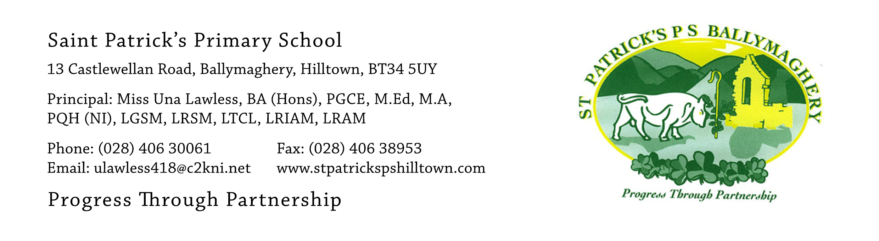

14th July 2021
Dear Parents,
Regarding our letter of 29th June (see website news item of 29th June) about arrangements for pupils returning to school on 31st August there have been some queries from parents which I will answer in this letter.

Water bottles: Each child will need their own bottle filled with water daily. We will be unable to use the water fountains on a shared basis in the coming term and it is not possible for children to drink the water from the classroom taps.

Starting Time: As school starts at 9am pupils should aim to be walking through the buzzer gate by 8.50am. This will give them time to walk to their classrooms and wash their hands before class starts at 9am.

Uniform: Pupils in P.1 and P.2 will wear a tracksuit and yellow t-shirt five days weekly. Pupils in P.3 – P.7 will wear a tracksuit two days each week, when they have P.E., and the full uniform on the other three days. Full uniform consists of a yellow shirt or blouse, tie, pinafore or skirt for girls and trousers for boys along with the bottle green jumper with the yellow ‘V’ and the school crest. Pupils may wear black shoes or trainers. This applies to all children in P.3 – P.7. We are very proud of our lovely school uniform. The children look extremely smart when they are dressed in full uniform and their self-respect, self-esteem, self-image and self-confidence develop when they know that they look well.

We are always immensely proud of our P.7 pupils who set the standard for everything that happens in the school and all the younger pupils look up to them as an example with regard to behaviour, uniform and work. We know that this will continue in the years ahead.

The full range of our school uniforms are currently in stock in SM Shoes in Rathfriland, Mc Evoys, Newry and Saints and Scholars, Newry. While being extremely good value for money in terms of the amount of time a child will wear them, we appreciate that uniforms are an added expense for parents. We draw your attention to the website news item of 15th June about applying for EA uniform assistance. Families who are experiencing financial hardship with regard to uniform provision are invited to contact the school at: ulawless418@c2kni.net

We are hoping that the children will be able to attend school for the full year in 2021-2022 as the last two years have been disruptive and unsettling. However, the children have been marvelously resilient and with your continued support we will get as many things back to normal as soon as possible in the 2021-2022 year.

Children attending the Summer Scheme are having a great time. Today we had an exciting visit from ‘Phil’s Farm’! I hope that everyone else is also having a lovely summer break!

Yours faithfully,
Una Lawless

