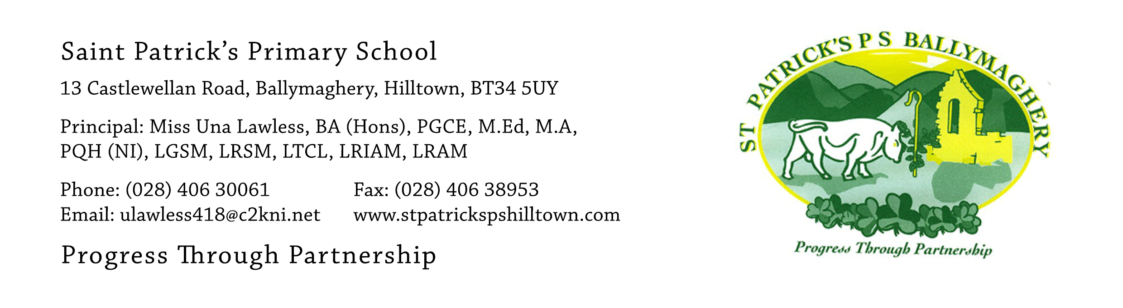

2nd November 2020

Dear Parent,

This week all pupils in P.4 – P.7 are spending time in class learning about Internet Safety.
We ask you to read our up-dated E-Safety Policy which is on the website, along with the Code of Practice for Parents regarding E-Safety Rules.
We also ask that you read through the page on ‘AN ACCEPTABLE USE OF THE INTERNET’ which your child will bring home and that both you and your child print and sign your name at the bottom of the page and then return it to the class teacher tomorrow.
We are all aware that technology which uses the internet is an important feature of modern society. Most adults and many children now own mobile phones. These have many wonderful uses and many of us could not imagine life without them. However, the increasing sophistication of mobile technology presents many difficult safety issues for children and young people. As a school we have to pay attention to these dangers on behalf of our pupils.
Children of primary school age need to be given very clear boundaries by their parents regarding their use of technology. Most of the social networking apps such as ‘WhatsApp’ and ‘Snapchat’ are entirely unsuitable for our children. Teachers of pupils from P.4 – P.7 will spend curriculum time in the coming weeks educating children about the dangers of modern technology – not to scare them but to help protect them.
This will have no effect at all unless parents are fully involved in this process. Please use the E-safety documents on our website to have full and frank discussions with your child about this important issue. Please ensure that Parental Guards are in place on all the technology your child uses in the home and outside of school.
If you have any concerns about any aspect of internet safety please get in touch with me.

Yours faithfully,

Una Lawless
Principal

