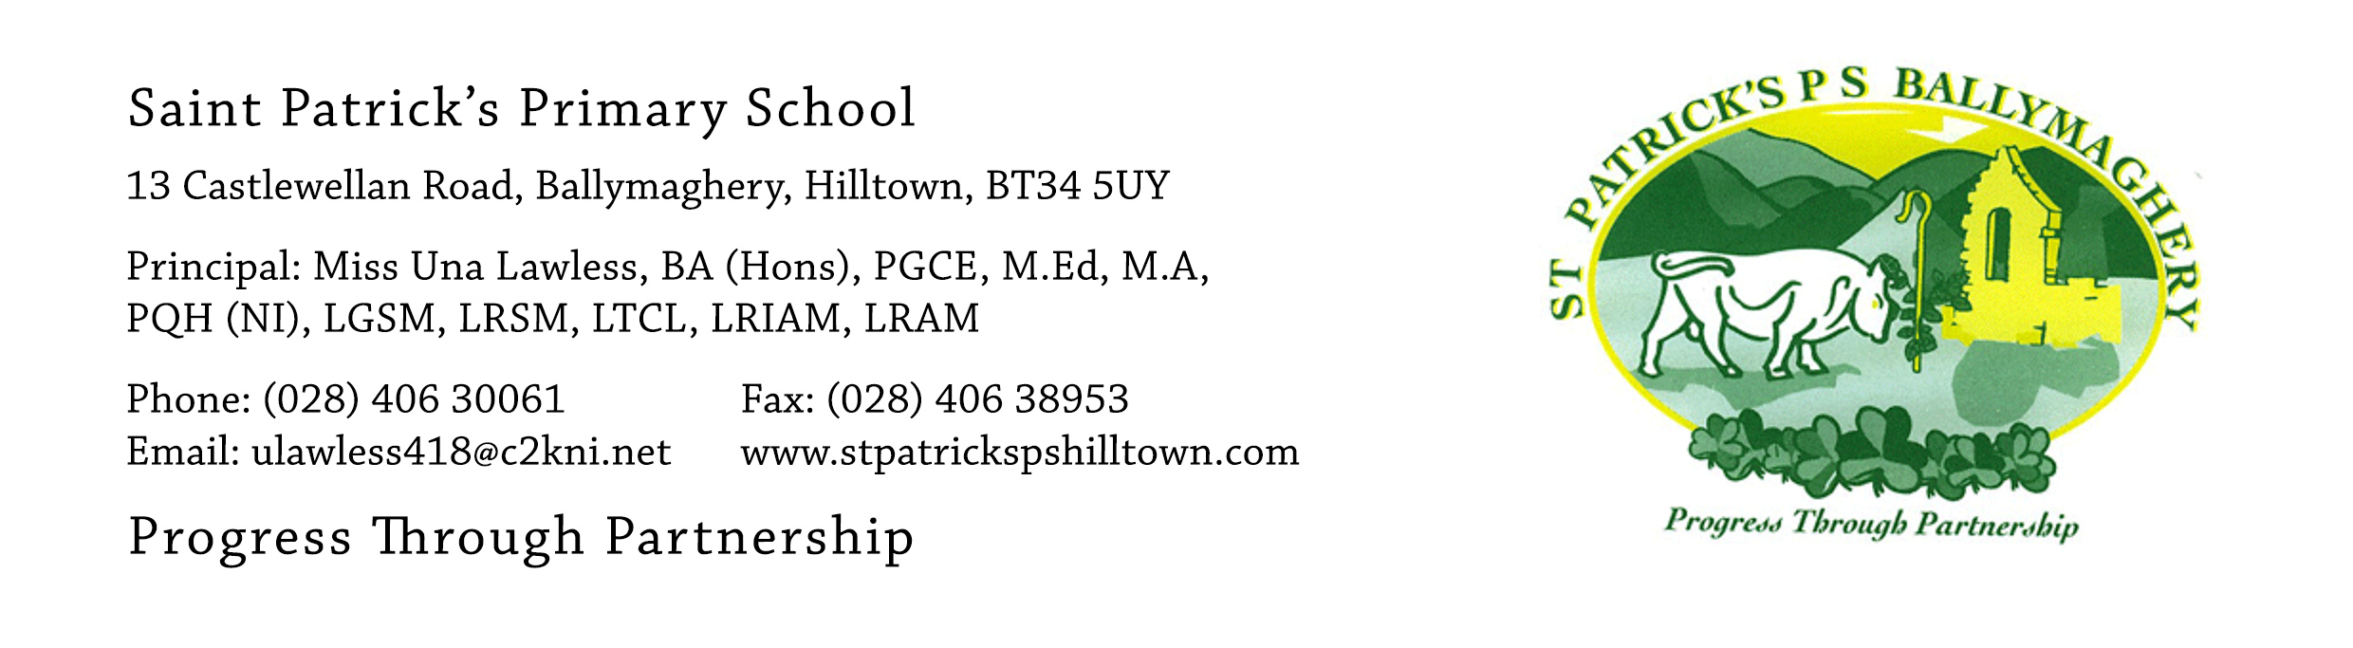

30th June 2021

Dear Parents,

In Una’s own words ‘all things must come to an end’ and sadly they must. I would like, on behalf of the Board of Govenors, to sincerely thank Una for her twenty-six years of service in the education of the children of St Patrick’s and especially her last six years as Principal.

Una, in her tenure as Principal, has led the school with great distinction and professionalism. She has maintained and built on the very strong foundations which have been established in St Patrick’s over a long number of years by the current and former staff and Principals and which leave our school in great shape, ready to face the future and no doubt the many challenges that lie ahead.

On a personal note, I would like to thank Una for all her kindness and courtesy extended to me over the many years I have known her and on behalf of our whole school community, I would like to wish Una well in her future endeavours and give my best wishes for a long and happy retirement.

Yours Sincerely,

Eugene Byrne

Eugene Byrne (Chair of St Patrick’s Board of Governors)

