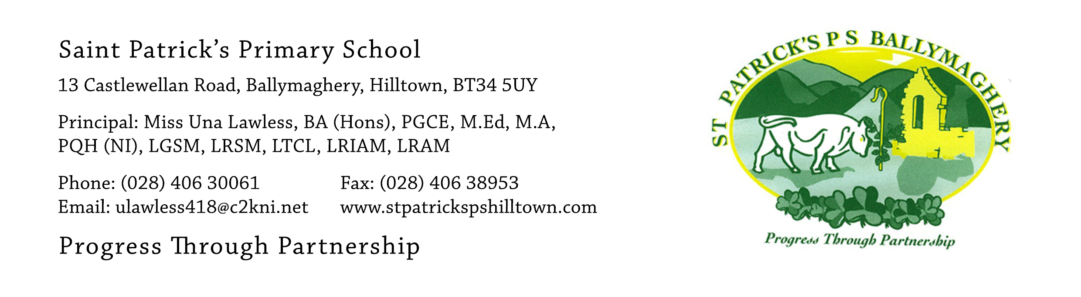

29th June 2021

Return to school on 31st August 2021

Dear Parents,

As we reach the end of the school year, I want to take this opportunity to thank you all, most sincerely, for your wonderful support of the school throughout this challenging year. Thank you for the great work you did at home during the period of school closure in January, February and March and for supporting your child with their learning throughout the rest of the year.

Thank you also for your wonderful generosity in the retirement gifts you gave me. I really enjoyed the outdoor concert presented by the pupils and the outdoor mass was a lovely blessing for everyone.

Our Senior Leadership Team met recently to plan ahead for the return to school in September and we are hoping to make some significant changes back towards normality.

These are as follows:
- Uniform: Pupils in P.1 and P.2 will wear a tracksuit and yellow t-shirt five days weekly, as currently. Pupils in P.3 – P.7 will wear a tracksuit two days each week, when they have P.E. and full school uniform on the other three days. Full school uniform consists of a yellow shirt or blouse, tie, pinafore or skirt for girls and trousers for boys along with the bottle green jumper with the yellow ‘V’ and the school crest. Pupils may wear black shoes or trainers.
- Homework: all classes will return to normal homework. Homework will be completed in an exercise book (P.4 – P.7) or folder (P.1 – P.3) and will be corrected in class by the teacher as it was in previous years. Teachers will explain the processes involved in this with their class when homework starts in September.
- School bag: Pupils will bring a school bag to school each day.
- Lunchbox: Pupils will bring a lunchbox to school each day if they are taking lunch.
- Water: there will still be no sharing of water fountains so pupils will bring their own bottle of water to school each day.
- Hygiene: NO wipes or sanitisers are brought to school by pupils. Pupils will continue the good practice of washing their hands with soap and water at regular intervals during the school day. Pupils are encouraged to bring a packet of tissues to catch sneezes or coughs.
- Starting Time: School starts at 9am. The buzzer gate will be opened at 8.40am and pupils will walk to their own classroom and be met by their own teacher. We will use all entrance doors as in the 2020-2021 year and pupils will be shown which door they use daily when they return to school on 31st August. Pupils will wash their hands before school starts.
- Home-time: We will inform you in August if there will need to be staggered home-times, based on DE guidance. We hope to be able to return to normal home-times of 1.50pm on Monday-Thursday for P.1 - P.3 pupils and 3pm on Monday to Thursday for P.4 - P.7 pupils. For the first term we will keep the staggered home-times on Friday and this will be reviewed at Christmas. This means that pupils in P.1 – P.3 and their older siblings will go home at 1.30pm each Friday. Pupils in P.4 and P.5 and their older siblings will go home at 1.40pm and pupils in P.6 and P.7 will go home at 1.50pm each Friday.
- Pencil Cases: only pupils in P.5, P.6 and P.7 will bring pencil cases. These should contain 2 pencils, 2 pens, a rubber, a sharpener, a small ruler and a small set of colouring pencils. Pupils in P.1 – P.4 will be provided with all the writing/drawing/colouring equipment they need in the classroom and should keep their personal writing equipment at home.
- After-school activities: it is hoped that we will be able to re-start some after-school activities. This will depend on guidance from the Department of Education.
- Dinners: We wish to remind parents that all dinner money is paid on a Monday for the week. It is sent to school in a clearly labelled envelope with individual envelopes for each child. Money for siblings will not be accepted in the one envelope. We thank you for doing this so well in the 2020-2021 year as it saved lots of teaching time.

Have a lovely summer! Hopefully there will be lots of good weather to enjoy. We look forward to seeing many of you at the Summer Scheme in July.

Yours faithfully,

Una Lawless

