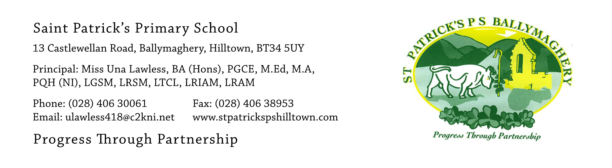

20th May 2021

SPONSORED FUN FIT SESSION FOR SCHOOL FUNDS

Dear Parents,

We would like to thank you for your generous support of the school this year.
Our Sponsored Walk in September raised the magnificent amount of £5583.30. The sale of Gift Sets with the pen, torch and keyring earlier this month was very popular and we made £240 profit.

Our final fund-raising event for school funds this year takes place next week as the weather forecast for the week is good, with no rain forecast!
There are two aims:
1. to raise money for school funds;
2. to let the children have fun through participating in healthy, outdoor activity

Today each child will bring home a Sponsor Card. We would ask the children to do their best to get sponsorship from family and friends. There will be a small prize for the child in each class who brings in the most sponsorship money and a news item will be put onto our website and into local newspapers.

With the help of their teacher, children will set a target for themselves in four physical activities – jumping, skipping, hopping and walking. These targets will be realistic and not overly demanding.
The jumping, hopping and skipping session will take place in the school playgrounds. Classes will do the walk individually, in their class bubble with the teacher and a classroom assistant walking with each class. This physical activity will be enjoyable and fits in well with our on-going objective this year of getting the children outside for outdoor learning and play as much as possible.

Children should return the card and money in an envelope to their class teacher by Thursday 27th May with the total amount raised clearly marked on the sponsor card and on the outside of the envelope.

We thank you, in advance, for your support of this event which we hope will be enjoyable for every child.

Yours faithfully,

Una Lawless

