TRÓCAIRE 2021
Please give generously!

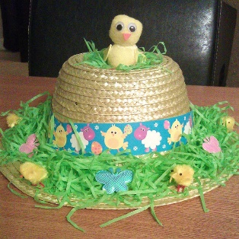
We are having a special “Easter” day on Tuesday 30th March.

Wear your own clothes and an Easter bonnet, cap or hair decoration!
Suggested donation of £2 per child.
Thank you!

