ST PATRICK’S PRIMARY SCHOOL, HILLTOWN


Policy for Educational visits
AUGUST 2025

Progress through partnership

St Patrick’s Primary School Ballymaghery :

OUR VISION
St Patrick's Primary School is a catholic school where staff, governors and parents are committed to progressing in partnership to provide the right for each child to learn to become the best they can be in a respectful, inclusive, caring, and hardworking community.

OUR VALUES
We are R.I.C.H.

Respectful Inclusive Caring Honest & Hardworking
Our Mission Statement
- St Patrick’s Primary School is a welcoming Catholic community centred on Christ, where His Values and Gospel message are lived in out through life in our school, in our thoughts, words and deeds.
- We are committed to working in partnership with the home and parish in developing each child’s personality, talents and abilities to the highest standards, in a mutually supportive and caring environment
- We will nurture in our pupils, respect for their own self-worth and promote a spirit of inclusion and tolerance towards others with recognition of the value of other people, regardless of gender, ability, social or cultural background.
- We expect all in our community to work hard to achieve our aims.
- We show our commitment to working as a learning school through:
- Continuing professional development of all staff.
- Reflective practice in learning and teaching.
- Listening to the pupil voice.
- Promoting and sharing of good practice.

Our Aims
- To promote a caring, inclusive environment where our Catholic ideals, values, and beliefs form the foundation of our school whole community through home, school and parish.
- To cultivate in children respect for themselves and others, where they have a healthy tolerance for all beliefs and respect for property and environment.
- To help each child grow and develop spiritually, morally, intellectually, culturally, emotionally and physically so they become caring and responsible citizens of the future.
- To develop a positive growth mind-set towards life and a love of learning.
- To give the opportunity to achieve the highest standard of skill and knowledge in all curricular activities enabling our children to become articulate, literate and numerate with early intervention in place as required.
- To develop enquiring, imaginative and creative minds with the ability to question and reason rationally, enabling them to become highly motivated, independent and confident life-long learners in an ever-changing society.
- To develop the skills to help them understand their world through scientific, historical, geographical and religious inquiry and to foster an awareness of their responsibilities to care for their local and wider community and environment, and of the effects their actions can have on them.
- To ensure our children become independent and confident learners through innovative teaching in a stimulating well-resourced learning environment.
- To strengthen our partnership where Staff, School Governors, Parents/Guardians and community work with each other for the successful achievement of these aims.
- To endorse the United Nations’ Convention on the Rights of the Child and work towards the implementation of policies and practices which reflect the Convention;

BACKGROUND AND CONTEXT

Children derive considerable benefit from taking part in educational visits. In particular, they should have opportunities to participate in activities and gain from experiences not available in the normal classroom setting. Such educational visits help children to develop a wide range of valuable personal and social skills. At St Patrick’s staff members appreciate the wonderful potential of school trips and we are keen to offer pupils a range of memorable opportunities to enhance their daily education which takes place within the school grounds. Safety is of paramount importance and to ensure clarity and consistency of good practice it is our policy to take the following actions before and during a school trip. This policy has been written in accordance with E.A. guidelines (October 2017).

LEGAL CONTEXT
The employing authority is legally obliged to ensure that the health and safety of the
employees and pupils in their care is safeguarded. This duty is imposed through occupational health and safety statute, specifically under the ‘Health and Safety at Work (N.I.) Order’ 1978, and places responsibility upon employing authorities to ensure that their management arrangements in general, (but also those arrangements which encompass specific activities such as educational visits) are adequate to protect the health and safety of all those in any way affected by such employer’s undertakings.

The manner in which such arrangements are developed is through the process of a risk assessment, the outcome of which acts as the basis for the staff to establish what needs to be put in place to allow the visit to proceed in a way which sufficiently manages the risks to which participants may be exposed.

The board of governors of a school has a statutory duty under Article 7 of the Education and Libraries (NI) Order 2003, to safeguard and promote the welfare of registered pupils at the school at all times when the pupils are in the lawful control or charge of a member of staff of the school.

The legal framework to protect children from harm is primarily provided by the Children (Northern Ireland) Order 1995 which became law on 4 November 1996 and repeals virtually all pre-existing legislation concerned with child protection. The central thrust of the Order is that the welfare of the pupil must be the paramount consideration and it is this essential principle which underpins effective practice in the area of child protection.

The basic principles of child protection must always be borne in mind when undertaking an educational visit. The pupil’s welfare must always be paramount and this overrides all other considerations. All pupils have the fundamental right to be protected from harm.
Pupils have a right to be heard, to be listened to and to be taken seriously.
Careful consideration must be given to pupils who have special educational needs, as such children may be especially vulnerable.

CATEGORIES OF EDUCATIONAL VISITS

Trips undertaken by the pupils of St Patrick’s will not involve an overnight stay and

will be in categories 1 and 2 of the E.A. guidelines.

CATE
Category 1: Basic
Visits which take place on a regular basis and occur largely within establishment hours e.g. sporting fixtures, swimming pool visits and outings.

Category 2: One-off day /evening excursions
For example: field study trips, theatre visits, business/education visits, regional sporting fixtures.

RISK ASSESSMENT
In St Patrick’s P.S. we undertake a Risk Assessment before every trip. (Appendix 1). Educational visits cannot be entirely risk-free. The aim, therefore, must be to contain risks within acceptable levels. Care must be taken not to expose the child to unacceptable physical or psychological risk, particularly on those occasions when the educational visit aims to exercise the individual’s sense of adventure.
Fundamental to the planning process of any educational visit is the process of risk assessment.
Staff at the venue should be asked to provide evidence that they have undertaken a risk
assessment and that it is a safe location for the children.

SUPERVISION AND STAFF RATIOS
Supervisory roles should be closely aligned to the roles and responsibilities undertaken by staff on a visit. Pupil to staff ratios for educational visits are not prescribed in law.
There will be a full complement of adult supervision as recommended in E.A. guidelines, as
follows:

 | AGE GROUP | RATIOS
PRIMARY | Foundation Stage (P1/P2) | one adult for up to a maximum of ten children
PRIMARY | Key Stages 1 and 2 (P3-P7) | one adult for up to a maximum of fifteen children

Among the supervisors there should be one who is trained in First Aid. There should be a staff
member who is identified as the group leader. The group leader must have a contact number for
each member of staff accompanying the group. Each supervisor should have a written list of
names of children in their care.

VETTING
In the context of educational visits we follow the school’s Child Protection Policy and
procedures. All supervision will be undertaken by staff members who have had a full police
check carried out by E.A.. Students from Higher Educational Institutes who are on placement in
the school and have had appropriate police checks carried out by their training institution
may also be supervisors on trips.

TRANSPORT
The management of the school must be satisfied that all the transport arrangements meet the legal statutory requirements for the type of journey proposed. Only companies approved by E.A. will supply transport. The transport selected must provide each child with a single seat and while in a bus, taxi or car the child must be protected by a seat belt.

Where leaders or parents choose to transport pupils in their cars, we will:
- satisfy ourselves that the vehicle is licensed and insured for purpose – this could involve asking for a copy of the insurance details;
- seek the agreement of the parents of the pupils involved – this should be in writing;
- satisfy ourselves that private car users do not carry more passengers than the number of seat belts available;
- do so in accordance with the school Private Car Transport Policy.

COMMUNICATING WITH PARENTS
In St Patrick’s we have an effective, two-way communication process between the
school, centre and parents for all visits. This ensures that parents are made aware of the
purpose and nature of the visit and will ensure that parents inform the school about any
particular needs and issues of their child relevant to the visit.

Information to parents may include:
- the aims and benefits of the visit;
- dates of the visit or series of visits;
- destination details;
- times of departure and return and whether parents will be required to meet their children on return;
- the location where the pupils will be collected and returned;
- mode(s) of travel including the name of any travel company;

Parent Consent
Parental consent must be obtained for educational visits. This will be done for each visit or outing.

Volunteers in a Supervisory Role
To satisfy staffing ratios, it may be necessary to involve persons other than staff members as
volunteers, e.g. parents. These adults can play a very valuable part in ensuring the safety of
group participants while on a visit. However, prior to any visit they should be clear about their
role and responsibilities during the visit.

Critical Incidents
“A critical incident may be defined as any sudden and unexpected incident or sequence of events which causes trauma within a school community and which overwhelms the normal coping mechanisms of that school.” (iMatter Every School a Good School. A Guide to Managing Critical Incidents in Schools).
In the event of a critical incident (as defined above) occurring during a school visit the school’s critical incident management plan will be implemented.

During the Visit:
The group leader must collect a cheque from the office for venue payment. The group leader must ensure that there are black bags for rubbish collection, a roll of tissue paper and plastic bags in the event that a pupil may be sick on the bus. A change of clothes should be brought in case of toileting or other accident. A First Aid Kit should be brought.
Children should be within the sight of the supervisor at all times. Supervisors should be aware of any dietary requirements or medical/physical assistance required by his/her group. Class groupings should stay together except where the venue requires them to break into smaller groups. On returning to school the supervisor should remain with the child until he/she has been collected by an adult or in the case of older children a check has been made to ensure that the correct procedures for going home are being followed.
Reporting back on return to school:
The Group Leader should report back to the Principal or Vice-Principal (or SLT member if principal and V.P. are unavailable) on return to school and provide an evaluation of the trip. Any incidents, accidents or injuries that have occurred should be reported. Accidents or injuries should be recorded in the School Accident book which is kept in Mrs Brown’s office. SLT members will advise regarding any action to be taken with reference to other incidents which occurred on a trip. Incidents should be recorded on the Incident Record Form (Appendix 2).
UNICEF Rights Respecting Schools programme:
We are a school committed to promoting the rights of our children. Our work in this aspect of school life promotes the following articles:
Article 3: The best interests of our children must be a top priority in all our actions.
Article 13: We have the right to find out things in various ways as long as it doesn’t harm or offend others in any way.
Article 31: We have the right to play and rest.

APPENDICES
Appendix 1: Risk Assessment Form for school trips/educational visits
Appendix 2: Educational Visit Incident Record Form

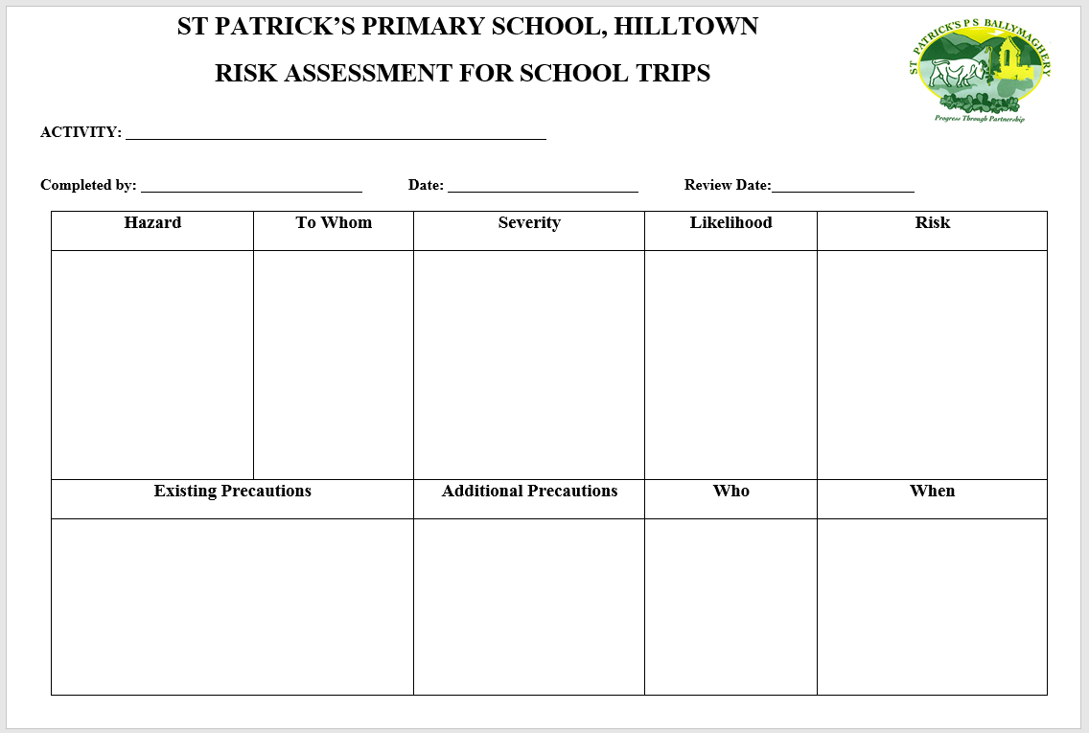

Educational Visit Incident Record Form Appendix 2
- Name of School

- Name of group leader

- Date, Time and Location of Incident

- Name and address(es) of witness(es)

(a) |  |  | (b)

- (Please state in your own words what happened including details of names and status of those involved

- Describe what action was taken (e.g. details of First-Aid, police or medical involvement)

Signed Date

