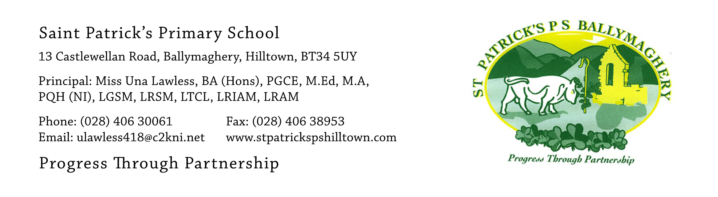

26th November 2020

Dear Parents,
I would like to start with a huge ‘thank you’ to all of you for the fantastic way you have been co-operating with us to help us keep the school open and all bubbles intact. Everything continues to go really well and all the children are learning and making progress.

Covid-19 Practices and Procedures
As promised, school staff have carried out our monthly review of all Covid-19 practices and procedures. All issues of concern identified were to do with the internal running of the school and our staff have put in place new measures to remedy these concerns.

Parent/Teacher Meetings
Parent/Teacher meetings for pupils who are not on an Education Plan will take place next week by phone or face-to-face, as arranged. Monday 30th November is a School Development Day and there is no school for pupils. If you are attending a face-to-face meeting on Monday 30th November or Tuesday 1st December there will be strict social distancing, and everyone entering the school building will be required to wear a face mask. Strictly no children are allowed to attend the parent/teacher meetings with their parents. Your child needs to have explained properly to you how you get to their classroom. There will be directional signs in the playground but no staff will be available to direct you on Monday.

Healthy Breaks
Our school has always encouraged children to have a healthy break. This means that children should only have water at break-time along with fresh fruit, dried fruit or vegetables. We have noticed that some children are not following this guidance and wish to give advance notice that we will start to strictly implement this from 5th January 2021.

Reminder – please bring a coat daily
We are now in the season of wind and rain and pupils must bring a coat every day as we are having outdoor learning as much as possible this year and classes are actively participating in
‘The Daily Mile’ programme.

P.1 Enrolment and P.7 Transition
Enrolment for new P.1 pupils and the process of transfer to Secondary Education for P.7 pupils will be online this year, including the up-loading of your child’s birth Certificate as part of the application. This service will be operated by the Education Authority (E.A.).

As yet the only details we have are as follows:
P.1 Enrolment for September 2021
Applications open online Thursday 7th January 2021
Applications close online Friday 29th January 2021
Placement letters will be issued by E.A. on 27th April to be received by parents on 28th April.
P.7 Transition for September 2021
Applications open online on Monday 1st March 2021
Applications close online on Tuesday 16th March 2021
Parents receive placement notification on Saturday 19th June 2021

These dates have been set by the Department of Education and the Education Authority.

The children are now all beginning to get excited about Christmas and our Christmas activities in school are well underway. Thanks to everyone who has bought Christmas raffle tickets and has donated food for the hampers and other raffle prizes.

Once again, thank you for your help and support. It is much appreciated.

Yours faithfully,

Una Lawless

