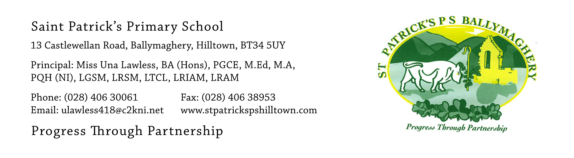

5th August 2020

Brief up-date regarding re-opening of school in August 2020

Dear Parents,

The summer is flying past and it will soon be time for children to put on their lovely green tracksuits and yellow t-shirts and return to school and see all their friends again! This is a very brief up-date to let you know that our plans are well underway to bring all the children safely back to full-time school on 1st September 2020 and we are very much looking forward to seeing them all again. We are also looking forward to welcoming our new P.1 pupils who have each received information on their individual schedule for starting school.

When the children return we are able to provide one metre social distancing for all classes with each child having their own desk or table. Pupils will also be in a ‘protective bubble’ which will provide further safeguards. We will follow all guidance from the Department of Education and from the Public Health Agency and we know that you will co-operate fully to enable us to implement all the necessary changes.

I would ask you to carefully re-read the letter which was sent to you via the website on 27th June 2020. This will clearly answer any questions you may have regarding uniform, school bags and lunchboxes and the need for each pupil to bring in their own tissues, hand sanitiser and anti-bacterial wipes for their personal use in the classroom. There are currently no changes to any of these matters which were explained clearly in the letter dated 26th June.

You will receive further information in the coming weeks. There will be many changes to the organisation of the school and to the running of the school day but the children will cope with these without difficulty. We are aware that some children will be anxious about their return to school and we are making a ‘Welcome Back’ video for the children to watch before their return. This will be put on the website on 21st August and will help to allay worries which some pupils may have.
Mrs Brown will phone parents on 17th August to let you know which two mornings your child will attend school during our induction week from 24th – 28th August. If you do not answer the phone she will leave a message on your mobile or landline. Please check your phones for a voice message on 17th August as she will not have time to phone again another day.
If you have any particular concerns about your child’s return to school please contact me at: ulawless418@c2kni.net

I look forward to welcoming your child/children back to St Patrick’s soon for what will be a different but great year at school!

Yours faithfully,
Una Lawless

