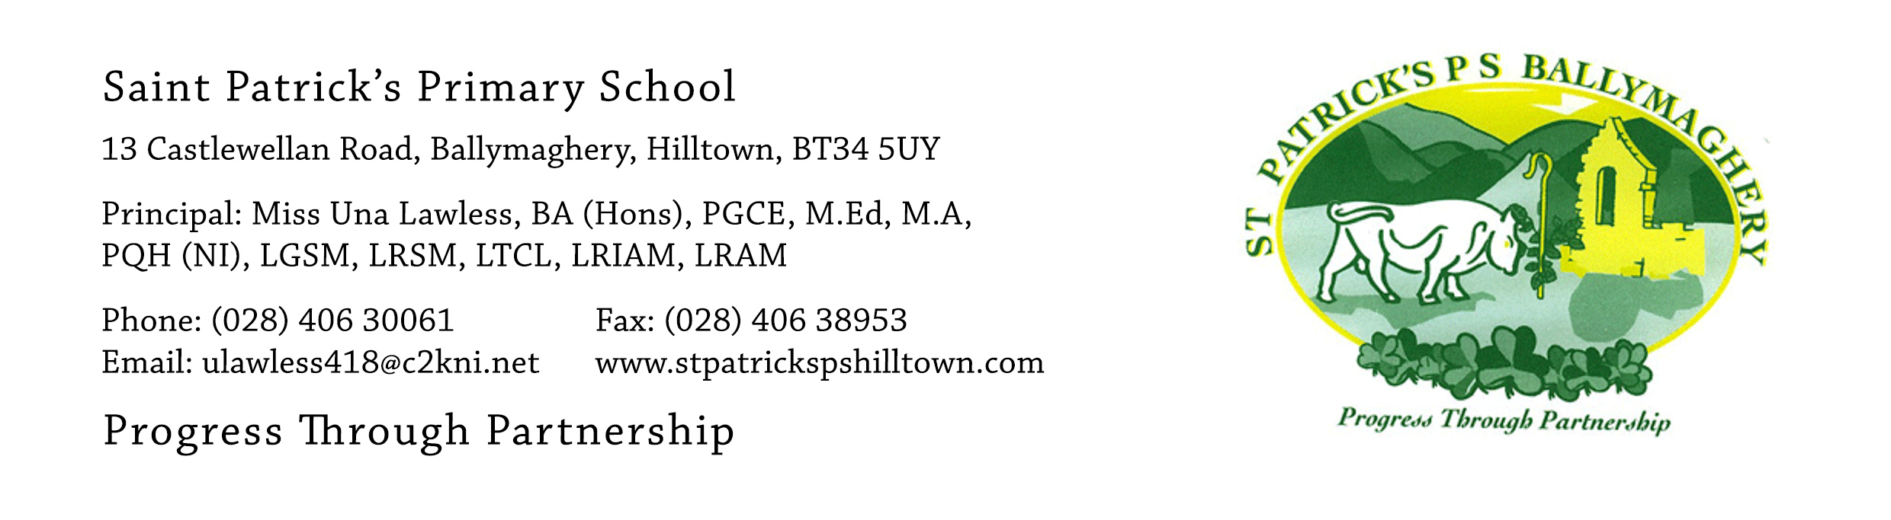

5th August 2020

Up-date regarding the sacrament of Confirmation

Dear Parents,

The summer is flying past and it is almost time to celebrate the sacrament of Confirmation for the children who finished at St Patrick’s on 24th June. We are all looking forward to the weekend immensely. To help your child prepare for the sacrament in this final week before their special day, Archbishop Eamon Martin has forwarded a link to a very useful resource:
https://www.icatholic.ie/come-holy-spirit-episode-1/
Just to remind you of the dates and times: the Confirmation mass will take place for the pupils who were in Room 12, Mr Mc Conville’s class, on Saturday 15th August at 3pm and the Confirmation mass for pupils who were in Room 11, Mr Crowley/Mrs Hearty’s class, will take place on Sunday 16th August at 3pm. Both masses will be celebrated by Father Charles Byrne.

At both masses social distancing will take place in accordance with the current guidelines. This means that each family will be allocated one row in the church with two empty rows in front of and two empty rows behind each family (2 metre social distancing). Up to eight people will fit into one row in the church. To make it as fair as possible rows in the church will be allocated in alphabetical order. All families enter the church by the main door (back of church) unless an alternative arrangement has been agreed with myself. When you arrive at the church please hand the filled-in Confirmation Card to Mrs Reavey (on Saturday) and Miss Murphy (on Sunday). Your family will then be directed to your seats and your family row will be clearly identified with your child’s confirmation certificate attached to the end of your row. There will also be four confirmation booklets placed in each family row.

Unfortunately we cannot have an entrance procession, offertory procession or sign of peace with hand shaking but we will involve as many children as possible in the other parts of the mass.
Pupils who are readers or musicians have been informed of this and are required to attend a rehearsal in the church on FRIDAY 14th August.

On Friday 14th August the timetable for rehearsal for the mass on Saturday 15th (Mr Mc Conville’s class) is:
2pm: Prayers of the Faithful
2.30pm: Liturgy of the Word
3pm: Singers
3.30pm: Instrumentalists

On Friday 14th August the timetable for rehearsal for the mass on Sunday 16th August (Mr Crowley/Mrs Hearty’s class) is:
4pm: Prayers of the Faithful
4.30pm: Liturgy of the Word
5pm: Singers
5.30pm: Instrumentalists

As the children have not rehearsed together for the mass, Father Byrne and I will give clear guidance during the mass as to what the children and their sponsors should do. There is no need for anyone to be anxious about what to do or when to do it.

The final hymn is ‘Go, the mass is ended’ and when it is over families are asked to leave the church row by row, using the back doors and side doors. Photographs may be taken outside the church and then families are free to go off and celebrate.

If you have any queries or concerns please contact me at: ulawless418@c2kni.net

I am very much looking forward to seeing you all on Saturday 15th or Sunday 16th for what I am sure will be very special confirmation masses.

Yours faithfully,
Una Lawless

