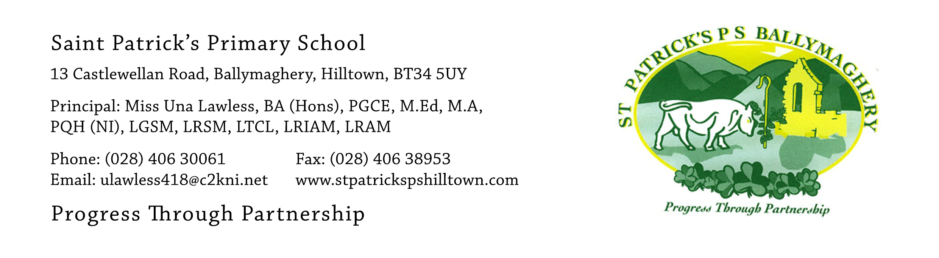

22nd June 2020

Dear Parents,
Archbishop Eamon Martin has met with the priests from the diocese of Dromore and given the go-ahead for parishes to celebrate the sacraments of Confirmation and First Holy Communion in August or September. Father Charles Byrne has met with local school Principals and dates have been agreed. We are delighted to let you know that the pupils from St Patrick’s P.S. Hilltown will celebrate Confirmation on the weekend of 15th/16th August.

The Confirmation mass will take place for the pupils from Room 12, Mr Mc Conville’s class, on Saturday 15th August at 3pm and the Confirmation mass for pupils from Room 11, Mr Crowley/Mrs Hearty’s class, will take place on Sunday 16th August at 3pm. Both masses will be celebrated by Father Charles Byrne.

In order to make it fair, choosing which P.7 class got Saturday 15th and which P.7 class got Sunday 16th was done as a raffle, with witnesses in attendance.

First Holy Communion will take place on Saturday 12th September. There will be two First Holy Communion masses – one at 11am and one at 1pm. There will be two P.5 classes with 25 pupils in each class in the 2020-2021 school year. One class will have their First Holy Communion mass at 11am and the other class will have their First Holy Communion mass at 1pm. When the pupils receive their school report this week they will be informed of their teacher for 2020-2021. The raffle to decide which class will attend the 11am mass and which class will attend the 1pm mass took place on Friday 19th June, with witnesses in attendance. Pupils will be informed of this outcome on Friday 26th June.

At all the masses social distancing will take place in accordance with the guidelines at the time. The guidelines may change. Under current guidelines (2 m social distancing) each family will be allocated one row in the church with two empty rows in front of and two empty rows behind each family. If this is the case all parts of the church will be used for family seating. If the guidelines are relaxed to 1m social distancing by August it will mean that there will only need to be one empty row in front of and behind each family which will mean that more family members could attend.

After all of the masses photos may be taken outside the church and then families are free to go off and celebrate. There will be no refreshments served in the school. We will keep you up-dated via the app and school website as we get nearer to the date of each celebration.

We are really pleased that the children will have their special day after waiting for so long. Although the Confirmation and First Holy Communion masses will not be the same as usual they will still be very special and perhaps even more memorable due to the current unusual situation we have all been living through. If you have any queries please get in touch with me.

Yours faithfully,
Una Lawless

