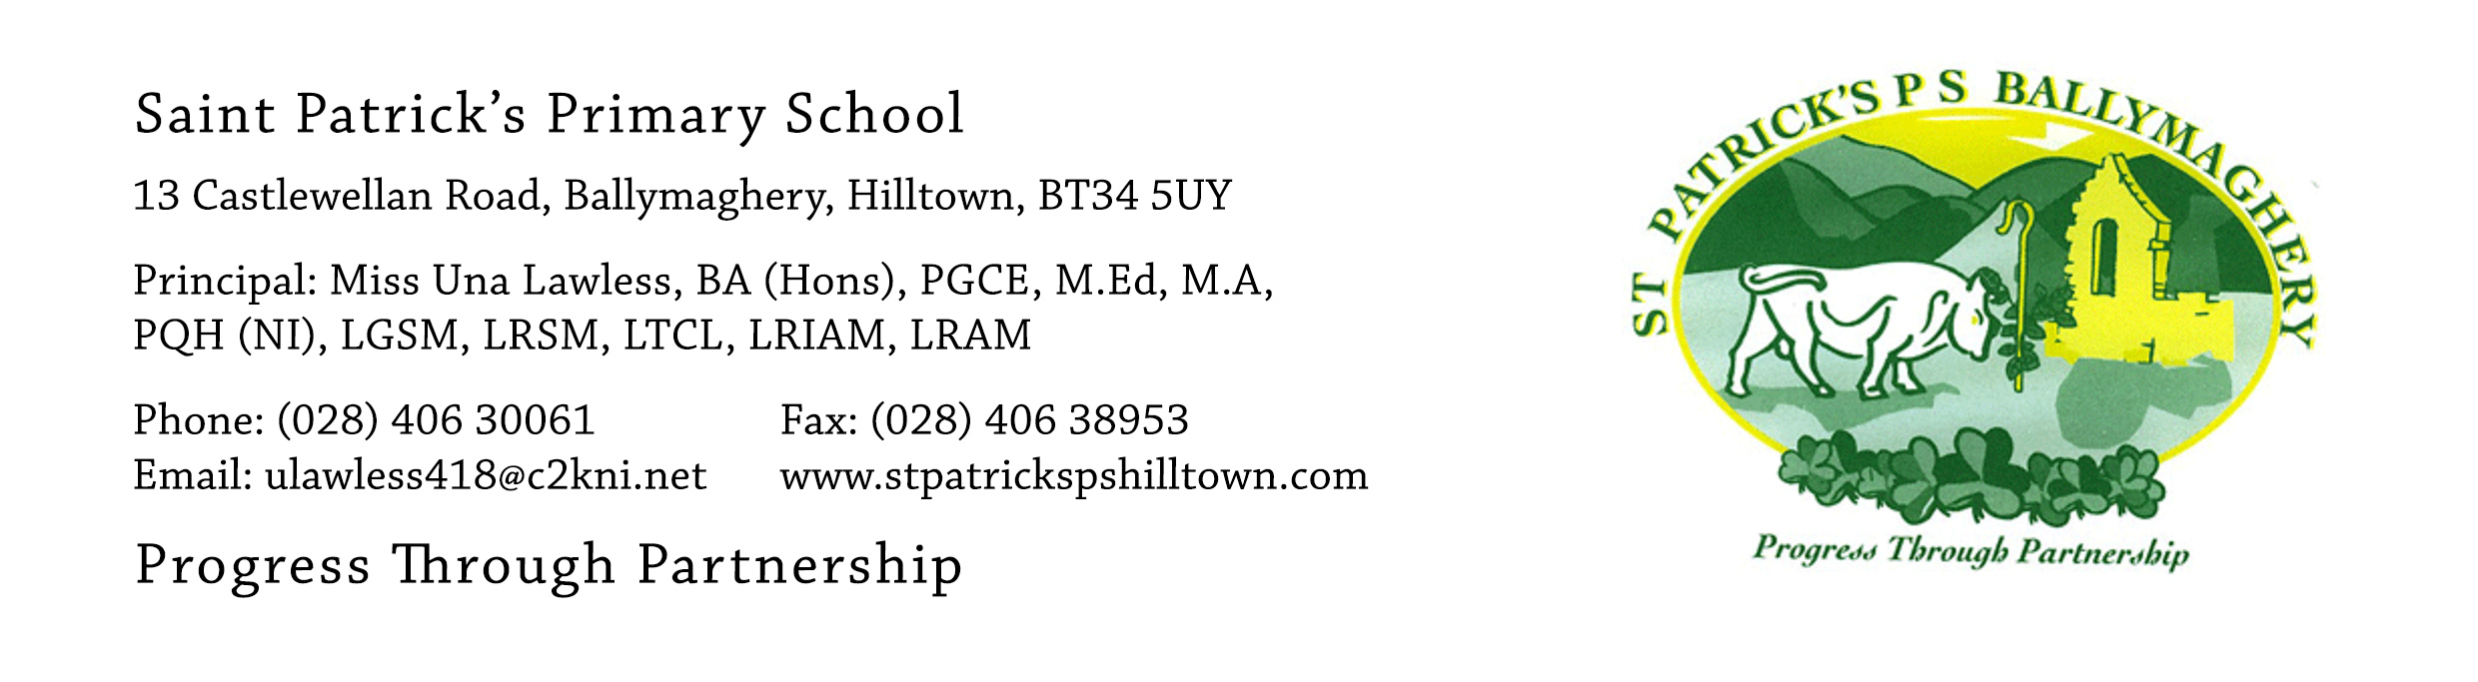

19th June 2020

Dear Parents,

Thank you so much for coming to the church carpark yesterday to return books and collect the children’s end-of-year things. Thank you also for the donations of books for our school library. It was lovely to see parents and it was especially lovely to see the children. It was also a little bit sad to say goodbye to them. However, I clearly got the impression from nearly all the children that they are ready to ‘move on’. This readiness has happened over the past 14 weeks as they have been at home and it shows that the human spirit (with the Holy Spirit within us) has a wonderful capacity to deal with and cope with unexpected changes and to make good come from them.

Our Primary 7 pupils finish school on Wednesday 24th June. Hip, hip, hooray for the lovely children! On that day we will mark their ‘leaving’ in two important ways. In the morning, at 11am, there will be a special end-of-year mass for everyone in the parish. Please take a look at the news item dated 9th June, on our website, about the mass. Daniel Devlin will represent all our P.7 pupils at the mass and he will read the Pupil Reflection. Live streaming is available on: https://watchmcnmedia.tv/camera/parish-of-clonduff-1

At 7pm on 24th June we will have our socially distanced farewell in the church carpark and the weather forecast is good!! We hope that each family will be able to attend (only one car for each family allowed). The event will last one hour and is a celebration of the children’s seven years in St Patrick’s. The main event is the P.7 video which lasts 45 minutes. It has been put together by Mr Crowley and I know that it will bring a tear to some of our eyes and many a smile and laugh!
Mr Eugene Byrne, our Chairman of the Board of Governors, will attend to represent the management of the school. I will say a few words (maybe more than a few words but hopefully not too many!).

On arrival at the carpark each child will be given a copy of the ‘P.7 Leavers Movie - the Class of 2020’ on dvd. The video details will also be emailed to each family on Thursday 25th June so that you can save a digital copy of it in Dropbox. If you have any problem with accessing the video in Dropbox please email the P.7 teachers email address by lunchtime on Friday 26th June (primary7stpatricks@gmail.com) and Mr Mc Conville will deal with all queries.

Sadly, this must be a socially distanced event. You all showed great respect for social distance on Thursday 18th and I know that you will do so again on Wednesday evening.

Our staff will direct cars as to where to park and cars will be parked the required distance from each other. The P.7 child from each family may stand outside the car at the driver’s door, if they wish. This will mean that the children will be able to see lots of their classmates. We ask all other family members to remain inside the car.

At the end of the video I suggest that we make lots of noise with horns and voices. As it will be a highly unusual event I think the children will always remember it! Our staff will then direct cars on exiting the carpark and a little patience will be required. Perhaps families may wish to have their own celebration at home afterwards in their garden or house. Your children are worth celebrating and you should also celebrate the amazing amount of hard work you have out in, as their parent, to get them to this stage of their life!

I would like to take this opportunity to thank you for all your support of the school and for your kindness and encouragement over the past seven years.

If you have any queries please contact me at: ulawless418@c2kni.net or email Mr Mc Conville or Mr Crowley at: primary7stpatricks@gmail.com

Yours faithfully,

Una Lawless

