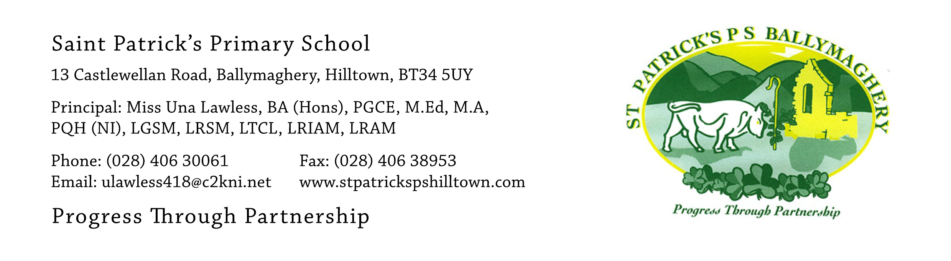

12th June 2020

Dear Parents,

Our Primary 1 – Primary 6 pupils finish school on Tuesday 30th June. The children have worked really hard during the twelve weeks of Home Learning and we are very proud of them. We want to say a big ‘thank you’ to all parents who have encouraged and helped the children with their learning in these weeks.

On our school calendar Monday 15th June was a Staff Development Day, with the children being off school that day, but the children had a holiday on 19th March instead so the teachers will set work on Seesaw for Monday 15th June.

The final week of work on Seesaw is 22nd – 26th June and we will now reduce the workload each week. When the summer holidays start it would be great if children keep on reading for pleasure every week.

I need the children to return all books which belong to the school. Please check all your cupboards, book shelves and school bags for text books, reading books and library books. Every child in P.1 – P.6 should have a reading book belonging to our Reading Schemes. Reading scheme books cost thousands of pounds and we seriously need all the reading books returned. Teachers will mark off the books on their list when children return them. If they are not returned in June teachers will keep on requesting their return in September. Please do a thorough search of your house now and get all books ready for return to school.

Teachers will put a list into Seesaw naming the type of books which each year group need to return eg reading diaries, times tables books…..

Timetable for return of books/collection of pupil work and pupil report

Monday 22nd June: 10am – 11.30am P.3 (Miss Mc Anulty)
Monday 22nd June: 12 – 1.30pm P.3/4 (Mrs O’Hare)
Monday 22nd June: 2pm – 3.30pm P.5 (Miss Lynch)
Tuesday 23rd June: 10am – 11.30am P.5 (Mr Trainor)
Tuesday 23rd June: 12noon – 1.30pm P.6 (Miss Murphy)
Tuesday 23rd June: 2pm – 3.30pm P.6 (Mr Flanagan)
Wednesday 24th June: 2pm- 3.30pm P.1/2 (Ms Mc Neill)
Thursday 25th June: 10am – 11.30am P.4 (Miss Fegan)
Thursday 25th June: 12noon – 1.30pm P.2 (Mrs Reavey)
Thursday 25th June: 2pm – 3.30pm P.1 (Mrs Austin)

This will be done with the same arrangements used when parents of P.7 pupils paid for the hoodies. There will be strict social distancing measures in place. Please park in the church carpark and queue up 2 metres apart (there will be cones in place to mark the social distances required). In the event that it is wet or windy the return of books will take place in the Parochial Hall with a one-way system in place. Again parents will park in the church car park and walk to the Parochial Hall past the Parochial House. When finished in the Parochial Hall parents will return to the church carpark by walking along the footpath at the front the school.

On the date and time specified above for your child one parent and the child may come to return their books. This will be an opportunity for the child to say goodbye to their teacher.

Please remember, when the books have been returned the teacher will then give the pupil their class work from the year and their School Report.

If you have any queries please contact me at: ulawless418@c2kni.net or email the class teachers at the year group email address. Thank you.

Yours faithfully,

Una Lawless

