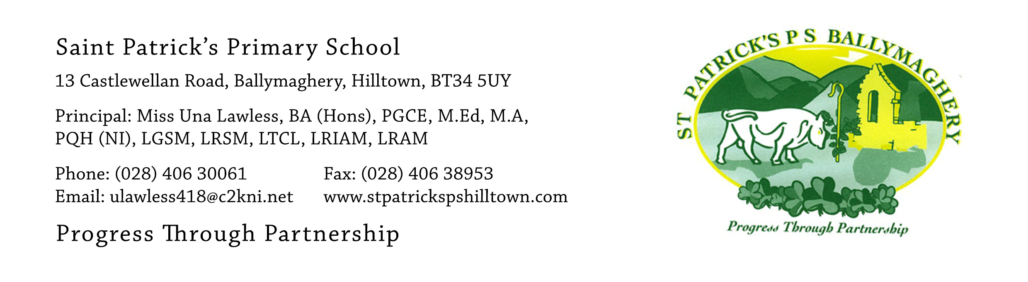

12th June 2020

Dear Parents,

Our Primary 7 pupils finish school on Wednesday 24th June. On that day we will mark their ‘leaving’ in two important ways. In the morning, at 11am, there will be a special end-of-year mass for everyone in the parish. Please take a look at the news item dated 9th June, on our website, about the mass. Daniel Devlin will represent all our P.7 pupils at the mass and he will read the Pupil Reflection.

At 7pm on 24th June we will have our socially distanced farewell in the church carpark (weather permitting). More details will follow on that next week. We hope that each family will be able to attend (only one car for each family allowed) and the event will last one hour.

The week from 15th – 19th June will be the final week of home learning for our P.7 pupils. The children have worked really hard during the twelve weeks of Home Learning and we are very proud of them. We also want to say a big ‘thank you’ to all parents who have encouraged and helped them with their learning in these weeks.

I need the children to return all books which belong to the school. Please check all your cupboards, book shelves and school bags for text books, reading books and library books. If your child in P.7 is the only or youngest child in your family you may wish to clear out a lot of reading books and novels which you have in your house and which are no longer of use to you. We welcome all donations of books in good condition for our school and class libraries.

We have a timetable for the return of books, as follows:
Thursday 18th June: 10am – 11.30am: P.7 pupils from Room 12, Mr Mc Conville
Thursday 18th June: 12noon – 1.30pm: P.7 pupils from Room 11, Mr Crowley

This will be done with the same arrangements used for paying the money for hoodies. There will be strict social distancing measures in place. Please park in the church carpark and queue up 2 metres apart (there will be cones in place to mark the social distances required). In the event that it is wet or windy the return of books will take place in the Parochial Hall with a one-way system in place. Again parents will park in the church car park and walk to the Parochial Hall past the Parochial House. When finished in the Parochial Hall parents will return to the church carpark by walking along the footpath at the front the school.

On Thursday 18th one parent and the P.7 child may come to return their books. This will be an opportunity for the child to say goodbye to their teacher.

When the books have been returned the teacher will then give the P.7 pupils some lovely things.
These will include:
- School books and work from the P.7 year
- School Report
- P.7 Award certificate and medal
- P.7 Yearbook
- Souvenir pen

If you have any queries please contact me at: ulawless418@c2kni.net or email Mr Mc Conville or Mr Crowley at: primary7stpatricks@gmail.com

Yours faithfully,

Una Lawless

