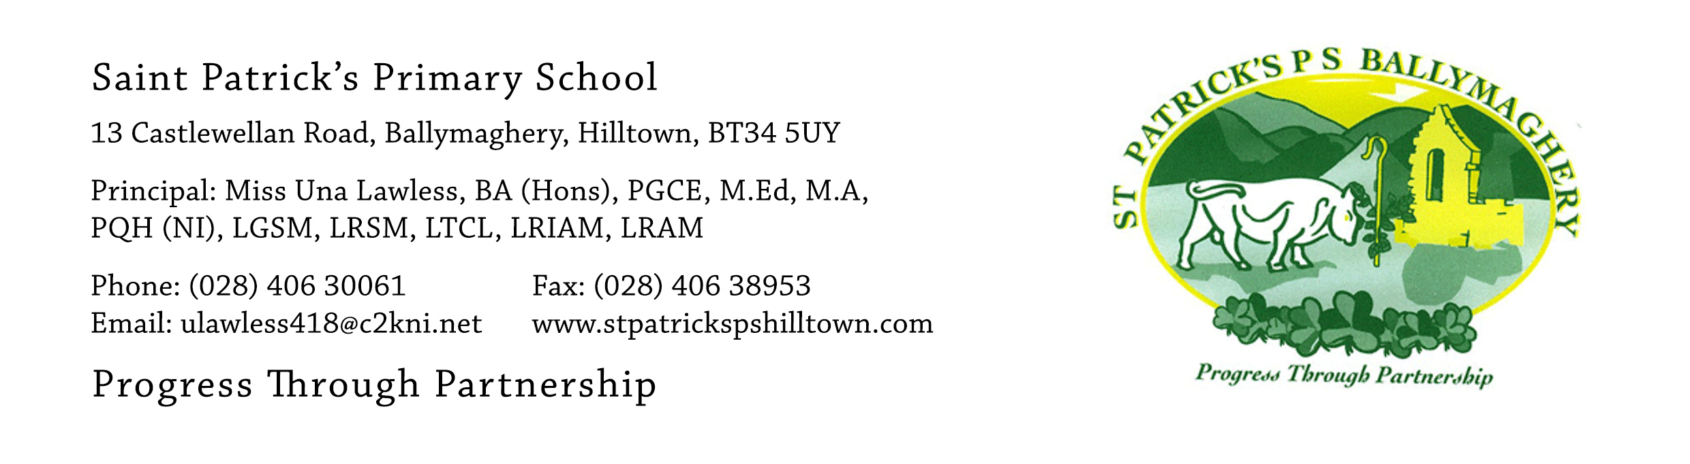

1st June 2020

Dear Parent,

We have now all had time to think about the information which was publicly announced by the local consortium of Grammar Schools on Friday afternoon. This stated that the five local grammar schools will suspend academic selection for the September 2021 intake.

Many of you have emailed me in the last few weeks to express your worries about your child having to take the Transfer Test in December, after such a disrupted period of education. The announcement on Friday takes away the anxiety and worry which parents and children have faced and would continue to face over the next six months.

This announcement means that your child can start back in September along with other year groups. You will not have to buy the Holiday Test Pack and your child will not have to attend our planned Summer School. Although there is likely to be a phased return to school, the children can settle into a normal curriculum, where they will not have to undertake tests twice weekly. From this week, children no longer need to complete two tests each week but any child who wishes to continue to do the tests in the month of June, may do so. The children have put in so much effort over the period of school closure and have fully engaged with their teachers virtually and completed the work to such an excellent standard. Thank you to all parents for your support of the children at this challenging time.

We will do everything possible to ensure that our P.7 pupils next year have a happy, enjoyable and academically worthwhile year, with lots of high-quality learning opportunities. Solid teaching and learning in Maths and Literacy will continue, but there will be no preparation for a Transfer Test.

We are very aware that suspending the use of academic selection for one year brings a new set of circumstances into play, which will affect all pupils and their families. All parents should check the 2020-2021 Admissions Criteria (the sub-criteria) of the schools they are interested in their child applying to, if you have not already done so. This will be found easily on each school’s website. For some families, the absence of academic selection will be a disappointment, while other families will welcome this change.

At St Patrick’s, we will do our best to help parents and children through the uncertainties of the coming year. We will continue to support the wellbeing of all the children. Like yourselves, we want what is best for each of them. Please feel free to contact me if you have questions or concerns.

Yours faithfully,

Una Lawless
Principal

