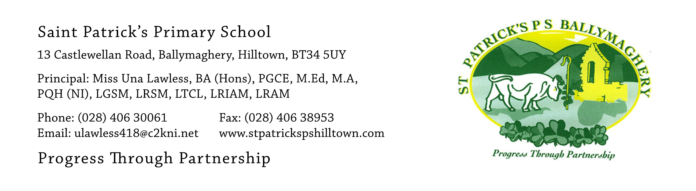

27th May 2020

Dear Parents,

Thank you for all the lovely suggestions which we received in relation to your children leaving St Patrick’s in these exceptional circumstances.

We have already made speedy progress on the two most popular of your requests – the ‘leavers’ hoodie and the P.7 video, and arrangements are well under way. Thank you for sending in your 15 second recordings so quickly and for ordering and paying for the hoodies so efficiently. We are delighted that all 58 children have ordered a hoodie.

The third most popular request was for a printed booklet, containing a photo and the name of each pupil and we are currently giving this request our attention. We will use the P.7 individual photo taken by CS Moments in February for this booklet. We wish to remind you that a class photo was taken by CS Moments in February and we will put a news item with details of this photo on our website today in case any of you would like to buy a copy of the P.7 class photograph in the coming weeks.

The fourth most popular request was that pupils would receive an end-of-year award, as all our pupils did last year. We are delighted to do this and the staff of St Patrick’s will identify a special talent, ability or area of strength for each child. Pupils will receive their award in the form of a medal and personalised certificate. These will be given to pupils along with their school report and a souvenir pen with the school name on it (as a keepsake). This will not be done in a public forum but will be private to the child and parents. There will be a date given on which each child is invited to collect their books, the envelope containing their report, medal, certificate and pen along with their hoodie. On that same day we request that pupils return all textbooks, library books and reading books belonging to school as we really need to get these back.

We had a small number of requests for a Zoom quiz, Zoom party or Zoom video call. We do not feel that any of these can be safely accommodated in the current circumstances.

We had requests for an end-of-year mass. We have arranged with Father Byrne that a celebration mass, with a special focus on the primary school leavers of the parish, will take place, via the webcam, on Wednesday 24th June at 11am. As all church ceremonies are subject to the current restrictions there will be three adults from St Paul’s P.S. Cabra and three adults from St Patrick’s P.S. Hilltown along with one pupil from each school attending the mass in the church. The pupil picked to represent each school will be chosen by picking a name out of a hat (in front of an independent witness) and he or she will be required to wear full school uniform at the mass.

There were requests for a ‘leaving event’. We hope to accommodate this on the evening of Wednesday 24th June by holding a socially distanced gathering in the church carpark at 7pm. We will organise it so that cars park two metres apart. As an outdoor event, this will be weather dependent. We will have a large screen and will show the P.7 video on this screen. The video will then be made available to parents by Dropbox (password protected) and these details will be emailed to families on Thursday 25th June. The video recording details will also be put into Seesaw on 25th June and we will try to make it available to a wider audience on our website (but this may not be possible if the video is too long as it may not up-load).

There were a few requests that pupils be invited back to St Patrick’s at some date in the future, when the Covid-19 situation has been resolved. We will be happy to invite our current P.7’s back next year as guests of honour when our current P.6 pupils perform their musical (as P.7’s). This would make it a visit with a purpose and it would undoubtedly be an enjoyable occasion for everyone. We also have Confirmation to look forward to, sometime in the future.

We hope that each child will be happy with these plans and that they give the children something to look forward to. These activities and events should help to give our pupils a sense of ‘closure’ and a chance to say ‘goodbye’ to St Patrick’s. The evening event on the 24th June will also give our staff an opportunity to say goodbye to the children, while still observing the required social distancing. It will not be a final ‘goodbye’. When things are normal again we are always happy to welcome past pupils in to say ‘hello’.

Please keep in touch during these final weeks. I am always available via my email address: ulawless418@c2kni.net

Yours faithfully,

Una Lawless

