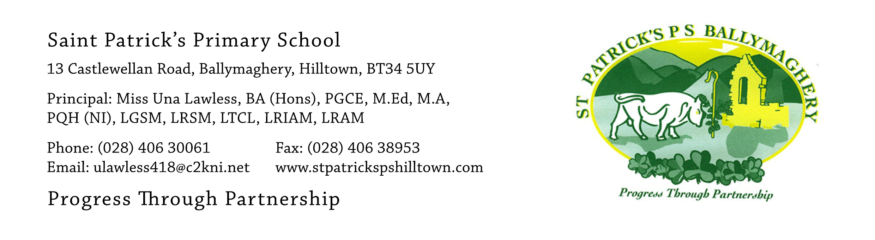

18th May 2020

Re: Hoodies for P.7 Leavers - the class of 2020. Orders by Thursday 21st May!!

Dear Parents,
Thank you for all your suggestions received by email in the past few days. I will get back to you later in the week with a summary of our responses to your great ideas.

One of the things we had thought of as a school staff was to provide pupils with an opportunity to purchase a school hoodie as a souvenir of their final year. This came back as the most popular suggestion from parents and we are delighted about this. It is, of course, entirely optional.

There is now a time constraint on this process which I why I am writing to you today.

If children are interested, a grey hoodie, with the school crest embroidered on the front and the year group list of names printed on the back may be ordered. These cost £21. Due to the highly unusual and unfortunate circumstances in which our school leavers find themselves this year I have requested our Parent Association to contribute towards the cost of the hoodies to make them more affordable. This is a once-off situation. On behalf of all the school families the Parent Association have kindly agreed to pay £6 towards each hoodie ordered which makes the cost of the hoodie £15.

A list of sizes is below for your information.

Size
Age 9-11 | 32 inch chest
Age 12-13 | 34 inch chest
S | 36 inch chest
M | 40 inch chest
L | 44 inch chest

Since pupils are unable to access samples it is important that the correct size is selected. Please measure your child to ensure that you order the correct size.

There are two methods available to order and pay for the hoodie.

- Post a cheque for £15 made payable to St Patrick’s Primary School, Hilltown to the school address to arrive by Thursday (posted on Tuesday 19th or Wednesday 20th May).
(St Patrick’s P.S., 13, Castlewellan Road, Hilltown Co. Down BT34 5UY)

Ensure that pupils name and size of hoodie is clearly stated on a page in the envelope.

- Pay £15 cash in an envelope. Only paper money will be accepted – no coins. To facilitate this method of payment I will be available on Thursday 21st May to take payment from parents. The school will not be opened.

Time
12 noon – 12.45 Mr Crowley’s P.7 class
12.45 – 1.30pm: Mr Mc Conville’s P.7 class

The following procedures will be adhered to in line with current restriction guidance.

- Park in church car park
- One person per family is permitted to make payment.
- The 2m social distancing measure will operate.
- Miss Lawless will receive payment at the gate of the church carpark

Thank you for your cooperation.

The order will be placed with the manufacturer on Friday 22nd May.

If you have any queries about the hoodies please email me today at: ulawless418@c2kni.net

Yours sincerely,

Una Lawless

