Management of Medical Conditions and
Prescribed Medicines (August 2025)

St Patrick’s Primary School Ballymaghery :
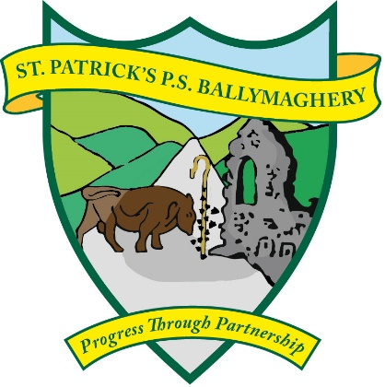

OUR VISION
St Patrick's Primary School is a catholic school where staff, governors and parents are committed to progressing in partnership to provide the right for each child to learn to become the best they can be in a respectful, inclusive, caring, and hardworking community.
OUR VALUES
We are R.I.C.H.

Respectful Inclusive Caring Honest & Hardworking
Our Mission Statement
- St Patrick’s Primary School is a welcoming Catholic community centred on Christ, where His Values and Gospel message are lived in out through life in our school, in our thoughts, words and deeds.
- We are committed to working in partnership with the home and parish in developing each child’s personality, talents and abilities to the highest standards, in a mutually supportive and caring environment
- We will nurture in our pupils, respect for their own self-worth and promote a spirit of inclusion and tolerance towards others with recognition of the value of other people, regardless of gender, ability, social or cultural background.
- We expect all in our community to work hard to achieve our aims.
- We show our commitment to working as a learning school through:
- Continuing professional development of all staff.
- Reflective practice in learning and teaching.
- Listening to the pupil voice.
- Promoting and sharing of good practice.

Our Aims
- To promote a caring, inclusive environment where our Catholic ideals, values, and beliefs form the foundation of our school whole community through home, school and parish.
- To cultivate in children respect for themselves and others, where they have a healthy tolerance for all beliefs and respect for property and environment.
- To help each child grow and develop spiritually, morally, intellectually, culturally, emotionally and physically so they become caring and responsible citizens of the future.
- To develop a positive growth mind-set towards life and a love of learning.
- To give the opportunity to achieve the highest standard of skill and knowledge in all curricular activities enabling our children to become articulate, literate and numerate with early intervention in place as required.
- To develop enquiring, imaginative and creative minds with the ability to question and reason rationally, enabling them to become highly motivated, independent and confident life-long learners in an ever-changing society.
- To develop the skills to help them understand their world through scientific, historical, geographical and religious inquiry and to foster an awareness of their responsibilities to care for their local and wider community and environment, and of the effects their actions can have on them.
- To ensure our children become independent and confident learners through innovative teaching in a stimulating well-resourced learning environment.
- To strengthen our partnership where Staff, School Governors, Parents/Guardians and community work with each other for the successful achievement of these aims.
- To endorse the United Nations’ Convention on the Rights of the Child and work towards the implementation of policies and practices which reflect the Convention;

An Introductory Document:
(Full Copies of our Medication Policy are available directly from School)

In St Patrick’s we endeavour to ensure that pupils who present with a particular medical condition receive the necessary care and support required.

To enable us to do this we are issuing the following guidance.
- Parents should complete the Medical/Allergies Form at the beginning of each school year.

- Please inform the school and update information if your child acquires a medical condition during the school year.

- If a child has a serious medical condition please make an appointment to discuss the situation with the Principal.

- Parents should be advised that the school will not as a matter of course administer medication to a pupil. Where a child requires essential medication during the school day parents should make arrangements to administer the medication themselves or nominate another adult.

- In exceptional circumstances where this may not be feasible, parents should discuss arrangements with the Principal.

- Pupils should not carry medication on their person or in their belongings at any time. Arrangements for management of medication should be agreed with the Principal.

- Following consultation, arrangements may be made to store essential medication in a safe and secure place within school.

- If a child presents with a life threatening condition, guidance will be sought from the Medical Officer and an appropriate Care Plan will be put in place.

- Where pupils suffer from a serious health condition, permission will be sought from parents/guardians to display photographs of children and relevant information in Staff Room to ensure that all Staff Personnel are made aware of the child’s condition.

