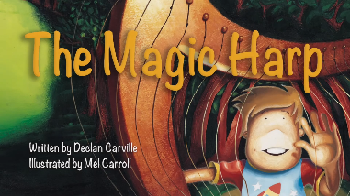

Our Three Word Book Reviews of “The Magic Harp”

Emma- Amazing, good, nice!
Finley- whimsical, relaxing story!
Louis- interesting, exciting story!
Cormac- Long, exciting story!
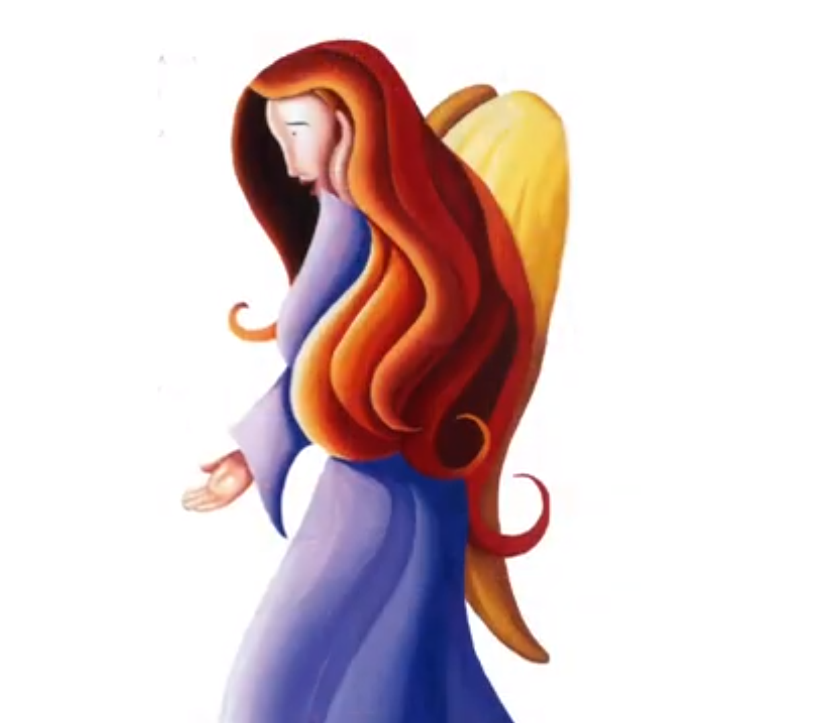
Peadar- fun, cool, exciting!
Shane- interesting, enjoyable story!
Aoife- magical, interesting, calm!
Daniel- funny, nice story!
Rihanna- enchanting, enjoyable, interesting!
Katie- imaginative, musical, dreamy!
Maggie McC- Exciting, amazing, classic!
Ella- cool, amazing story!
Paudie- nice and relaxing!
Maggie McG- Enchanting, relaxing, enjoyable!
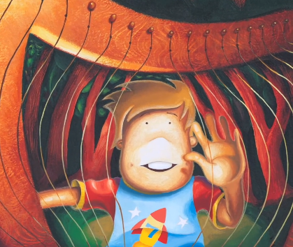
Grace- interesting, fun, exciting!
Callum- funny, exciting, cool!
Niall- chips, lunch, sisters!
Jack- Good, exciting, fun!
Olivia- happy, adventure story!
Padraig- fascinating, whimsical, good!
Owen- exciting, good, funny!
Jamie- good, good, good!
Annie- interesting, fun, relaxing!

