Internet Safety – Think, then Click!
I only use the internet when an adult is with me.

I tell an adult if I see anything online that
worries me.

I can only search the Internet when my teacher says it’s ok.

I immediately close any webpage I am unsure
about.

People I meet online may be strangers so I use
Stranger Danger!

I will not be unkind or mean to my friends or anyone else online. I know that words sent electronically can be very hurtful.

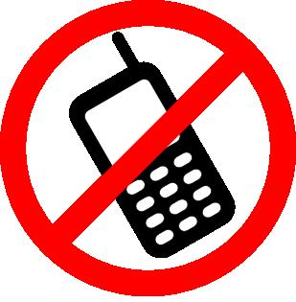
I am not allowed to bring mobile phones or any type of electronic devices to school!

Keep safe! Think, then Click!

