ST. PATRICK’S P.S. HILLTOWN

medication policy

April 2021

ProgRESS THROUGH PARTNERSHIP

Mission Statement

St Patrick’s Primary School, Hilltown, will provide a well ordered and caring environment in which the children can work and play. As part of a believing community committed to a Catholic way of life, we believe that all are equal in the sight of God and that each child should have the opportunity to ‘walk tall’ within themselves, knowing that they are important, whatever their individual talents and abilities. We strive to work in conjunction with the home and parish so that children can reach their full potential as well as growing in their own self-esteem, confidence and self-discipline. Children will be helped to develop an attitude of caring for and sharing with others, as well as cultivating a healthy tolerance for everyone’s beliefs and respect for their property and environment. We encourage shared responsibility among our pupils and reinforce good behaviour by actively encouraging and promoting qualities like patience, gentleness and a sense of ‘fair play’. We recognise the need for pupils to progress through a well-defined programme for work in all areas of the curriculum. Pupils will have access to relevant teaching and learning through a variety of teaching approaches. We will provide pupils with stimulating, enjoyable, rewarding and demanding experiences. We will match the curriculum to individual needs, with provision being made for more able children and those with special needs. Pupils will be encouraged to produce their own personal best, dependent on individual ability and aptitude. Resources in the school will be of a high standard and renewed as appropriate. The teaching and non-teaching staff, along with the principal and pupils will work in harmony to maintain a high standard of work, personal achievement and good behaviour. Our school motto is ‘Progress through Partnership’.
Our school is a UNICEF Rights Respecting School and Article 29 of the United Nations Convention on Rights of the Child (CRC) underlines our school’s vision:
‘Education must develop every child’s personality, talents and abilities to the full. It must encourage the child’s respect for human rights, as well as respect for their parents, their own and other cultures, and the environment.’

School Aims

In our school we aim to:

- Create a safe, enjoyable learning environment, in which effective learning is facilitated and quality teaching is provided;
- Implement all aspects of the Northern Ireland Curriculum;
- Help our pupils to develop a positive attitude towards life and a love of learning;
- Value, respect and nurture every child in our care;
- Encourage pupils to respect themselves and others, and to support and care for one another;
- Equip our children with the necessary life skills, to enable them to participate in a fast changing society;
- Develop and strengthen each pupil’s understanding and love of Catholic values, by promoting the Catholic ethos throughout the school;
- Endorse the United Nations’ Convention on the Rights of the Child and work towards the implementation of policies and practices which reflect the Convention; and
- Involve the parents, Board of Governors and wider community in the life of the school, and in the holistic development of the children in our care.

As a Rights Respecting School this policy is in line with Articles 3 and 24 of the United Nations Convention on the Rights of the Child.

Article 3: The best interests of the child must be a top priority in all decisions and actions that affect children’.

Article 24: ‘Every child has the right to the best possible health. Governments must provide good quality health care, clean water, nutritious food, and a clean environment and education on health and well-being so that children can stay healthy. Richer countries must help poorer countries achieve this’.

Medication Policy
Ideally, the administration of medication should be carried out by parents. Where possible it is the school’s policy to comply with requests from parents to help in administering medicines to children when these are of an essential nature (e.g. epilepsy, diabetes, asthma, anaphylaxis), during the school day.

The Principal will accept responsibility in principle for members of the school staff giving or supervising pupils taking prescribed medication during the school day where those members of staff have volunteered to do so.

Please note parents should keep their children at home if acutely unwell or infectious.

Parents are responsible for providing the Principal with comprehensive information regarding the pupil’s condition and medication.

Prescribed medication will not be accepted in school without parental completion of “Parental Agreement for School/Setting to Administer Medicine” form (appendix 1). Antibiotics should be administered at home.

Staff will not give a non-prescribed medicine to a child unless there is specific prior written permission from the parents.

Only reasonable quantities of medication should be supplied to the school (for example, a maximum of four weeks supply at any one time).

Each item of medication must be delivered to the Principal or Authorised Person, in normal circumstances by the parent, in a secure and labelled container as originally dispensed. Each item of medication must be clearly labelled with the following information:

● Pupil’s Name
● Name of medication
● Dosage
● Frequency of administration
● Date of dispensing
● Storage requirements (if important)
● Expiry date

The school will not accept items of medication in unlabelled containers.

Medication will be kept in a secure place, out of reach of pupils. Unless otherwise indicated all medication to be administered in school will be kept in a medicine cabinet.

The school will keep records of all medication administered (appendix 2).

If children refuse to take medicines, staff will not force them to do so, and will inform the parents of the refusal, as a matter of urgency, on the same day. If a refusal to take medicines results in an emergency, the school’s emergency procedures will be followed.

It is the responsibility of parents to:

- Notify the school in writing if the pupil’s need for medication has ceased.
- Renew the medication when supplies are running low and to ensure that the medication supplied is within its expiry date.

The school will not make changes to dosages on parental instructions.

School staff will not dispose of medicines. Medicines, which are in use and in date, should be collected by the parent at the end of each term. Date expired medicines or those no longer required for treatment will be returned immediately to the parent for transfer to a community pharmacist for safe disposal.

For each pupil with long-term or complex medication needs, the Principal will ensure that a Medical Care Plan and Protocol is drawn up, in conjunction with the appropriate health professionals.

Where it is appropriate to do so, pupils will be encouraged to administer their own medication, if necessary under staff supervision.

Staff who volunteer to assist in the administration of medication to a pupil with Medical Needs, for example, an Epi Pen for allergy, will receive appropriate training/guidance through arrangements made with the School Health Service.

The school will make every effort to continue the administration of medication to a pupil whilst on trips away from the school premises. However, there may be occasions when it may not be possible to include a pupil on a school trip if appropriate supervision cannot be guaranteed.

All staff will be made aware of the procedures to be followed in the event of an emergency.

APPENDIX 1: Parental Agreement form for school to administer medicine.

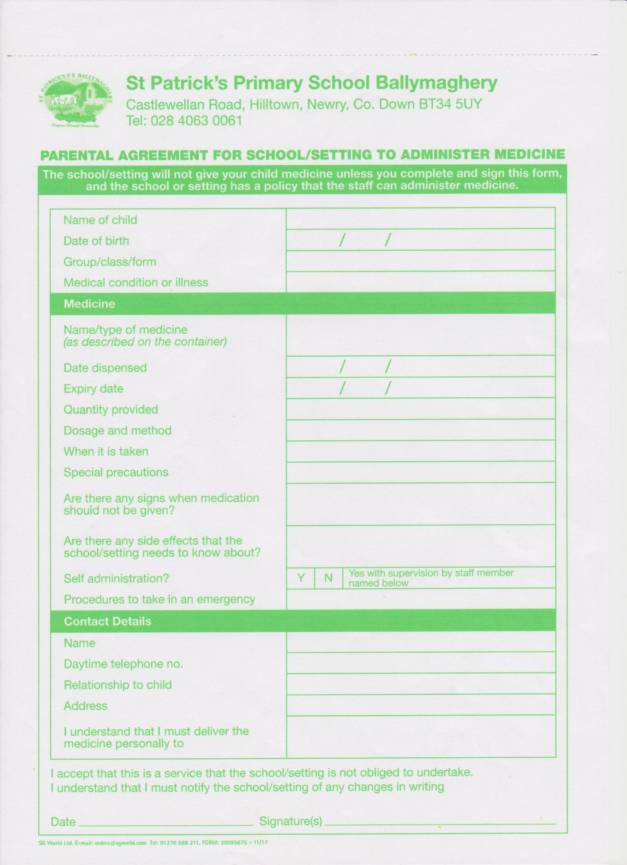

APPENDIX 2: Parental Notification form for medicine administered.

