ST. PATRICK’S P.S. HILLTOWN

treatment of head lice
poLICY

MARch 2021

ProgRESS THROUGH PARTNERSHIP

Policy for the Treatment of Head Lice

Rationale

The Northern Ireland regional policy for the control of head lice was first introduced on 24th March 1999 and reflects national guidance issued. The Southern Trust currently adhere to guidelines issued by the Department of Health and Social Services and Public Safety (2008).

Head lice are described in the regional policy as a problem of the wider community and not primarily a problem of schools. St Patrick’s Primary School does, however, recognise that as part of this community it can make a contribution by supporting parents in promoting and maintaining healthy, thriving children.

Principles
- Head lice are a problem of the whole community and are passed on by close family members and friends in the home and neighbourhood as well as in school.

- Head lice are transferred by direct, prolonged, head-to-head contact and while possible in the playground, it is unlikely in the classroom.

- Head lice infestation is not a serious physical health problem, however persistent head lice which is untreated is regarded as neglect and therefore could become a child protection issue.

- Clear diagnosis is important – treatment should only be started if a living, moving louse is discovered.

- The main responsibility for the identification of head lice is that of the parents or guardians. They should identify and treat any head lice problem and seek help from their doctor or health visitor if necessary. Further advice is also available on the NHS website – www.nhs.uk search head lice.

School Procedure

Information to help parents detect and treat suspected cases of head lice will be supplied as part of the school’s communication with parents.

Parents are urged, as in all health matters, to seek diagnosis from a medical professional and to treat the problem immediately for the benefit of the child, family and community.

If a member of staff sees a living, moving louse in a child’s hair every effort will be made to contact the parent on the day and inform them verbally. Should we be unable to inform the parent verbally a letter will be sent home. The reply slip should be signed and returned inside two days.
If no reply is obtained, or if the problem persists, the school nurse will be contacted.

The nurse may then contact the parents to offer advice and support.
Information will remain confidential at all times.
Children who have, or are thought to have, head lice will not be excluded from school.

HOW TO TREAT HEAD LICE

In order to prevent the spread of head lice in school it is important that you check your child’s hair regularly, and if necessary, treat thoroughly with any lotion recommended by a chemist or doctor. Routine head inspections are no longer carried out in schools but you may find the following information helpful.

How do you catch head lice?
Head lice cannot jump or fly. They like to live close to the scalp. They are only caught when two people’s heads are in contact for some time.

How do you know you have head lice?
Signs of head lice include: Live or dead lice in the hair, nits (empty egg cases), an itchy head, a rash round the neck or ears, dark gritty dust on pillows or collars.

A weekly family check for head lice
Wash the hair and using a fine-toothed comb (available from chemists), comb the wet hair from the roots over a sheet of white paper. If nits or eggs are found keep combing every other day for a week to ensure there are no live lice. If one is found, tell those in close contact and begin treatment.

Sometimes head lice return because treatment was not carried out thoroughly and eggs survived
Hair should not normally be treated more than twice in three weeks. If the problem persists, speak to the doctor.

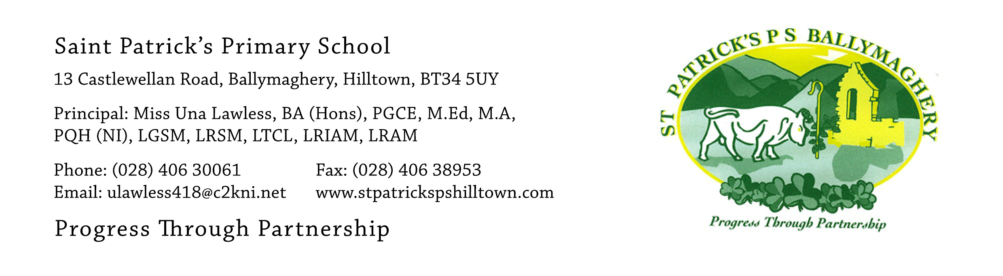

Dear Parent,
It has been reported to me that a head louse was seen in ‘s hair today.
There is no need to be alarmed. We may be wrong, but to avoid embarrassment I would ask you to check your child’s hair for yourself using a fine comb and, if required, treat the problem. Your doctor, health visitor or chemist will be able to provide you with further help and support.
As we will treat this matter in confidence there is no need to keep your child off school. I would, however, request that you return the slip below within two working days to confirm receipt of this letter.

Thank you.

Yours faithfully,

Una Lawless
Principal

----------------------------------------------------------------------------------------------------

St Patrick’s Primary School, Hilltown

I have received your letter dated regarding a possible case of head lice. I will check my child’s hair and treat any problem.

Signed: (Parent/Guardian)

